BIBD MINI PROJECT

Aim: Executing CRUD operations in MongoDB shell.
Steps:
- Start The MongoDB shell.

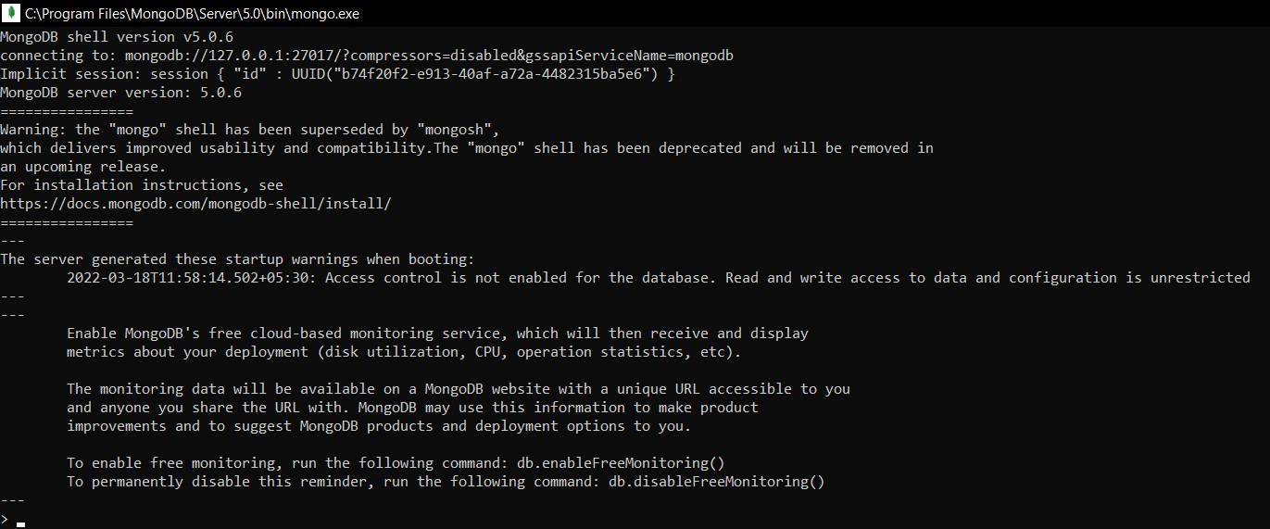
- Check for any existing databases.
- So, we do not have our own existing database, hence we’ll create a new one.
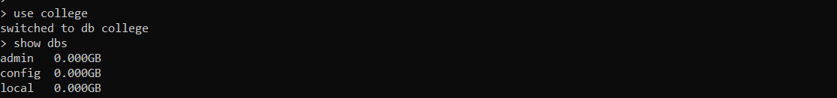
- We’ve created a database named college here, but it is not displayed because its empty, so we need to create a collection first inside this database. To insert document into collection json format is followed.
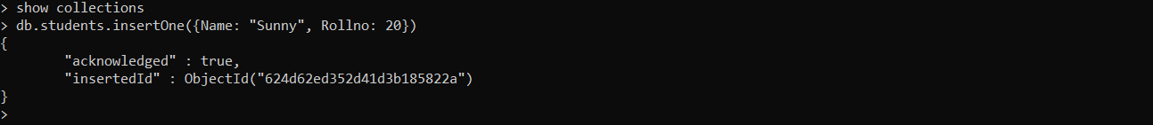
- Here, we’ve created a collection in the college database named students and added a document of one student. So now if we check the databases on the system we can see the school database.
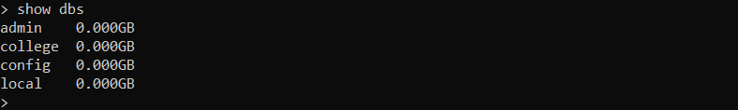

- Now, to check if the document is added in the collection we run:
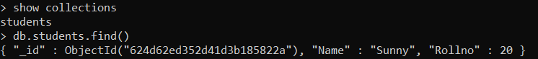
- So, the document we inserted earlier is shown here. If we want it in a more readable format we can use the pretty() function.
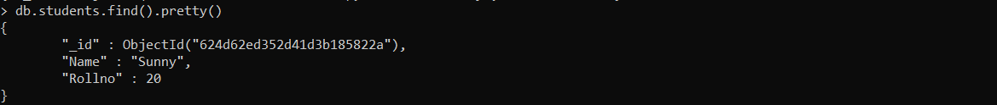
- We know how to create a database. Now let’s see how to delete/drop a database. Here, I’ve already created another sample database “dummydb” with document in it.
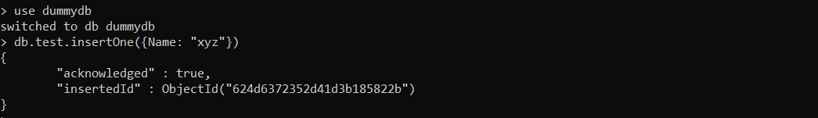
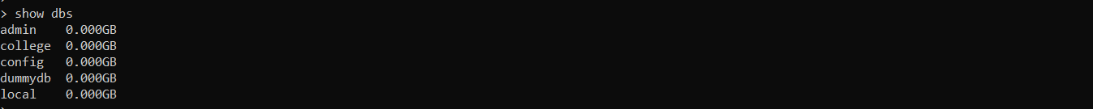
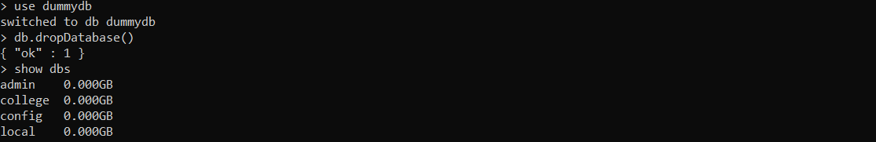
- To drop a single collection, you can do as follows:
- The basic CRUD operations include Create, Read, Update & Delete.

- The Create commands are of two types “insertOne(data, options)” & “insertMany([data], options)”.

- The Read command are of two types “find(filter, options)” & “findOne(filter, options)”.

- The Update command are of three types “updateOne(filter, data, options)” ; “updateMany(filter, data, options)” & “replaceOne(filter, data, options)”.

- The Delete command are of two types “deleteOne(filter, options)” & “deleteMany(filter, options)”.

- Executing the insertOne and insertMany commands:
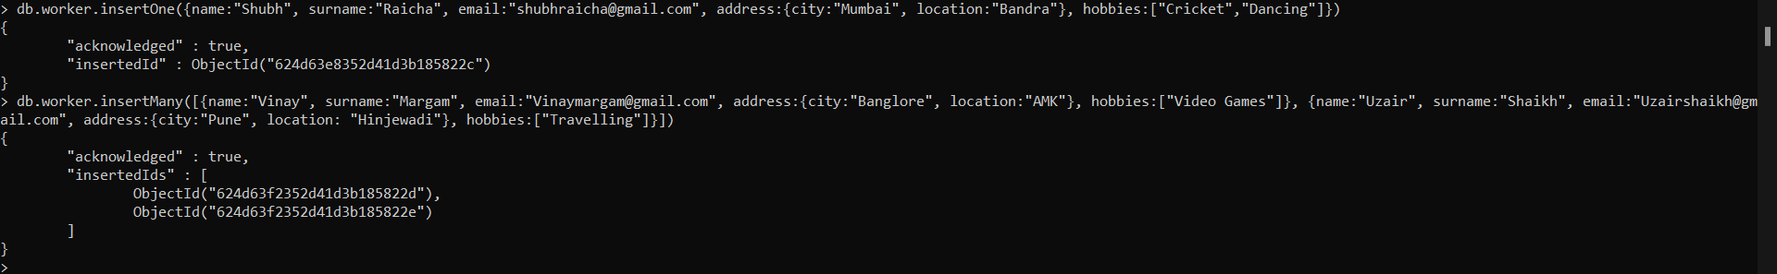

- Let us now check the database.
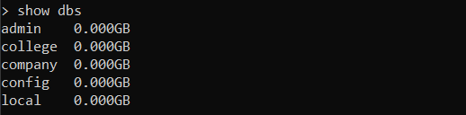

- Here check the records/document we have updated in the collection worker

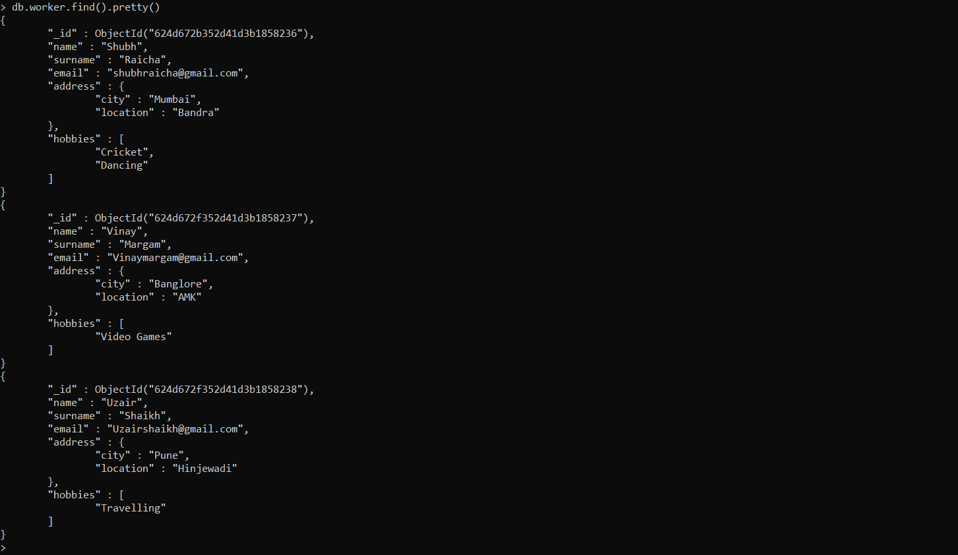

- Here, we’ve successfully executed the insertOne and insertMany commands and also Read the data in the Document.

- Now let’s try updating the location of Shubh to Thane in the document.

- Check if the value is updated:

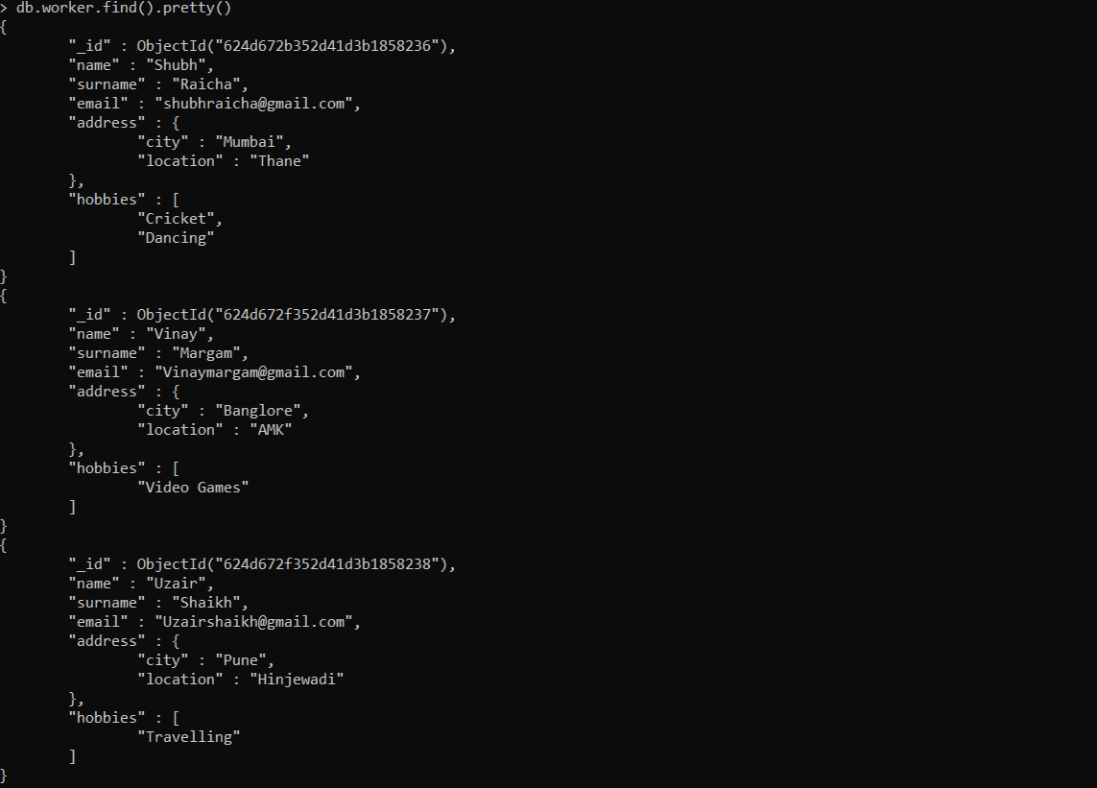

- Now lets try updateMany command

- Keeping the first parameter blank means updating all the entries.

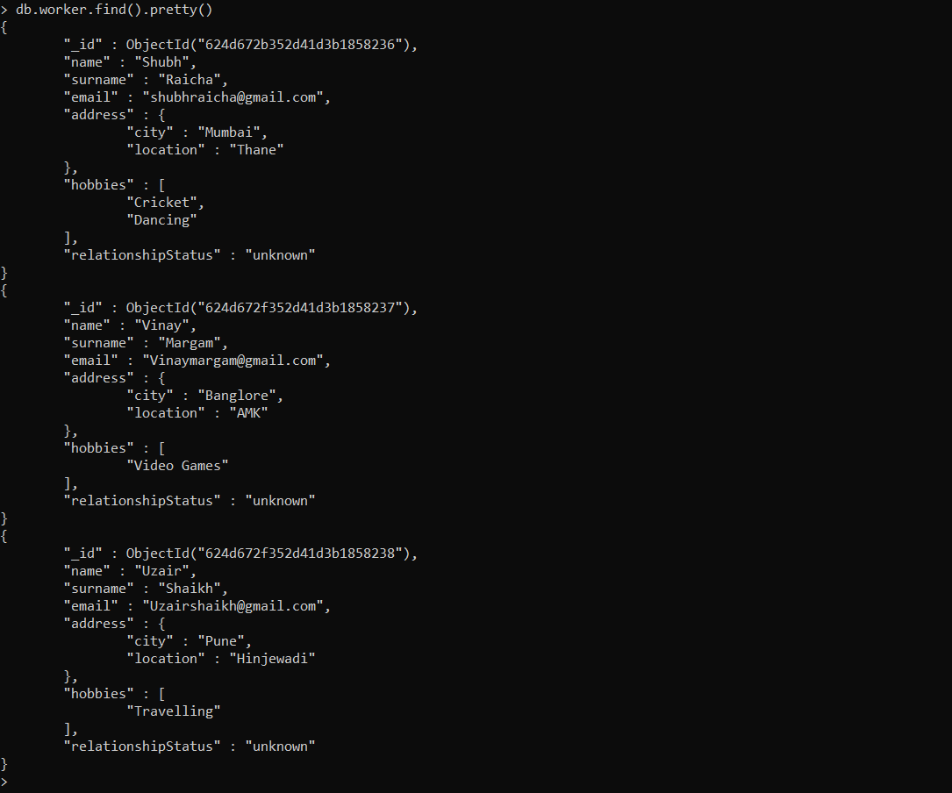

- Now let’s change status of one worker.

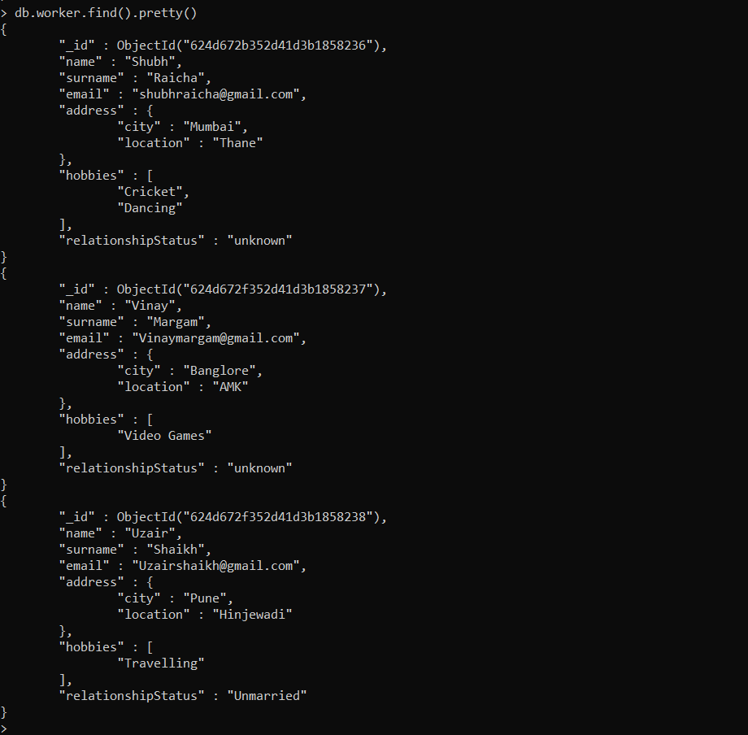

- Adding more data in collection and using Find() operations.
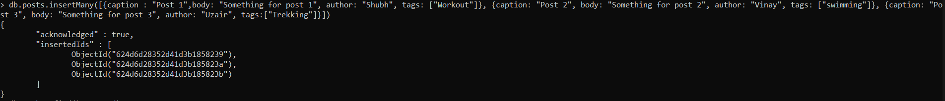
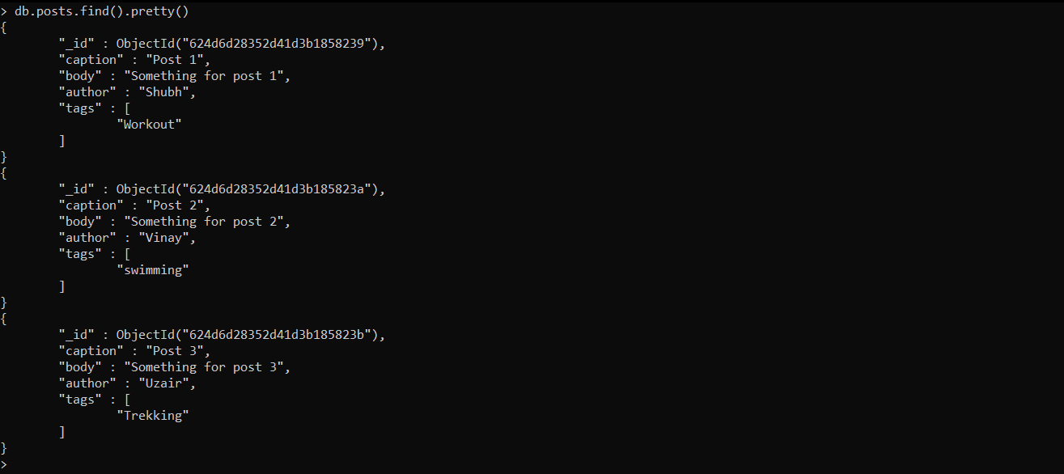

- Now using the Find command to find an entry with a particular tag.
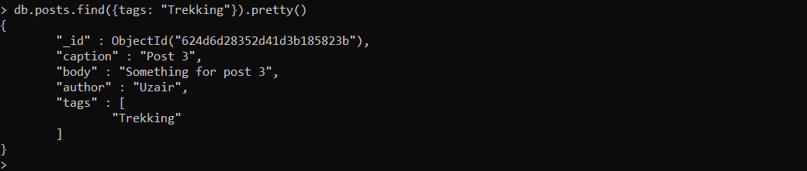
- To find other attributes of a particular tag we can specify the attribute using 0 or 1 as the value where 0 stands for False and 1 stands for True.
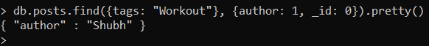
- Here the author is set to be True and _id is set to False hence ID is hidden and only author of the tag swimming is displayed.

- Now we can work on some delete operations.

- So now let’s delete an entry from employee using deleteOne() where relationshipStatus is Married.
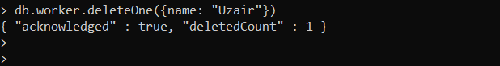

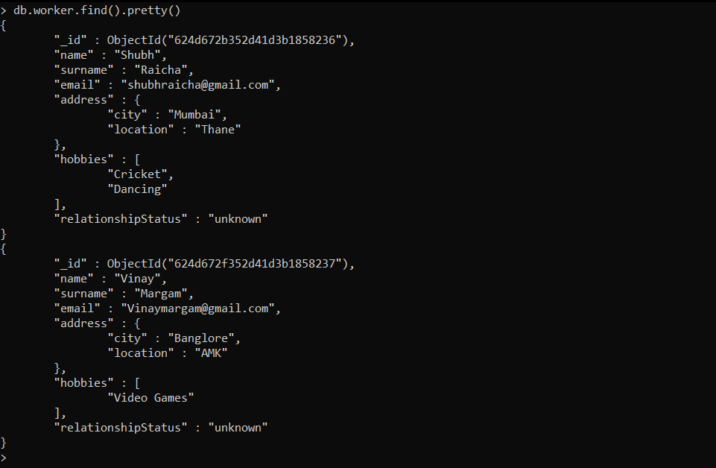

- Now deleting users with deleteMany() operations where relationshipStatus is unknown.
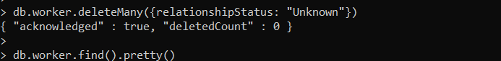
- All records are deleted and hence we now have an empty collection.

- This is all with the CRUD operations in MongoDB.

